Name Period
Evidence for Evolution WS
- Elements whose atoms give off radiation are called .
- A body part that is reduced in size and seems to have no function is called a . An example of this in humans is the .
- Body parts that are similar in their origin and structure are called .
- Remains of life from an earlier time are called .
- The method of dating fossils by their position in the rock layers is called .
- The study of the development of embryos is called .
- An example of a vestigial structure is .
- An example of a homologous structure is .
- According to radioactive dating, the Earth is years old.
- What scientists believe dinosaurs evolved into .
- Give two reasons why the fossil record is not complete .
- List three different ways organisms can be fossilized (or three different forms we find fossils in). .
- A basic rule we could use to describe the evolution of organisms are Earth might be .
- List five examples of evidence that support the theory of evolution. .
Look at the drawing of the layers of rock below. Each letter stands for a fossil. Answer the following questions about the drawing.

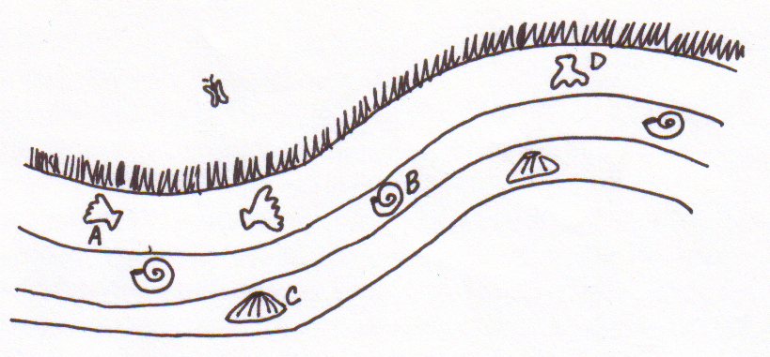

- Which fossil, the one at point A or point B, is older? Explain your answer.
- Which fossil, the one at point A or point D, is older? Explain your answer.
- Which fossil, the one at point A or point C, is older? Explain your answer.

