Phase of  Matter | Examples | Particle and Energy Description | Picture of Particles
Solid | Pen, comb, rocks, table | Particles are closely packed together or set into specific geometric shapes. They can’t move out of place, but they vibrate. Definite shape and definite volume. | 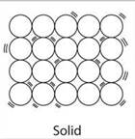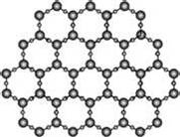
Liquid | Water, Kool-aid, gasoline | Particles still closely packed together but they have enough energy to slip around each other (flow). Indefinite shape and definite volume. | 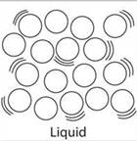
Gas | Air, oxygen, methane, carbon dioxide | Particles far apart. Have enough energy to separate completely from each other. Free to move in all directions until evenly spread out. Indefinite shape and indefinite volume. | 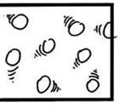

Temperature and energy increase as a substance moves from solid, to liquid, and then to gas.

