Name Date Period

Starter # 2

What does it mean to have definite shape?

[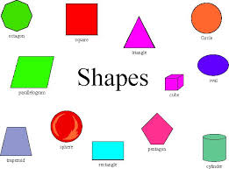](http://www.learnnc.org/lp/media/lessons/BeckyWoolard2112003458/Shapes.jpg)Which state of matter has definite shape?

What does it mean to have definite volume?

Which states of matter have definite volumes?



Name Date Period

Starter # 2

What does it mean to have definite shape?

[](http://www.learnnc.org/lp/media/lessons/BeckyWoolard2112003458/Shapes.jpg)Which state of matter has definite shape?

What does it mean to have definite volume?

Which states of matter have definite volumes?