The Story of Photosynthesis It all starts with the sun

Stage 1:

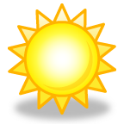



Close up of Stage 1 Stage 2:

Characters in this scene:

Close Up of Stage 2 We get the following products at

THE

END

Hmm…then what happens?