Name: Date:

Period: States of Matter Simulation Lab

**How do particles behave in different states?**

**Background Information:**

1. **Kinetic Energy:** The amount of energy of a particle due to its *__________________________.*
2. **Thermal Energy:** Measures the ­­­­_______________________________ of moving particles.
3. **Degrees Celsius:** The metric unit of measuring __________________________________.
4. **Temperature:** A measurement of the average ____________________________________ of particles.
5. **Kelvin:** Another unit of measuring ____________________.
   1. **K + 273.**15 = oC
   2. K= **oC + 273.15**
6. **The Particulate Model of Matter:** A model that explains that matter is made of ___________________________. The particles are always _______________________________ and have _________________ between them. Adding heat to the particles makes them _________________________________.

**Before you open the simulation, predict what you think we will observe:**

**PREDICT**

|  |  |  |  |
| --- | --- | --- | --- |
|  | Solid | Liquid | Gas |
| Diagram of particles |  |  |  |
| Sentence explaining how particles will be moving. |  |  |  |

1. Draw a diagram below showing what you think the particles will look like for each state of matter, solid, liquid, and gas. Write a sentence below each diagram predicting what the motion of the molecules will be like.

2. If you start with a substance as a solid, what will happen to the molecules as you add thermal energy (heat)?

3. Will the kinetic energy of a substance be greater in a gas, liquid or solid? Why? ____________________________________________________________________________________________________________________________________________________________________________________________________________________________________________________________

**ONCE YOU HAVE COMPLETED THIS PAGE, YOU MAY BEGIN THE SIMULATION.**

**PROCEDURE:**

* Open the internet browser and enter the address: <http://phet.colorado.edu>
* Click on “Play with sims” and select “Chemistry” from the menu on the left.
* Open the “States of Matter” Simulation and select “Run Now”. Be patient.

**OBSERVE**:

1. Complete the table below by exploring the “Solid, Liquid, Gas” tab in the simulation. **Test**your predictions and record your observations by recording the temperature and illustrations of each substance in the three states of matter.

|  |  |  |  |
| --- | --- | --- | --- |
| **Substances** | **Observations** | | |
|  | **Solid** | **Liquid** | **Gas** |
| **Neon** | Temperature:  Illustration: | Temperature:  Illustration: | Temperature:  Illustration: |
| **Argon** | Temperature:  Illustration: | Temperature:  Illustration: | Temperature:  Illustration: |
| **Oxygen** | Temperature:  Illustration: | Temperature:  Illustration: | Temperature:  Illustration: |
| **Water** | Temperature:  Illustration: | Temperature:  Illustration: | Temperature:  Illustration: |

2. Now, use the slider on the bottom of the program to Add Heat to water. Notice the thermometer at the top of the program. What temperature scale is this thermometer showing? ________________

3. What happens to the particle speed in each example as you increase the temperature? _________ ________ ______________________________________________________________________________

**STOP! Complete the Changes of State Notes with Mrs. Nicolai before continuing on.**

4. What is the melting/freezing point of water in Kelvin? __ ___

How do you know? ___________________________________________________________________

5. Add heat until the temperature is just below and then just above the melting point of water. How is water different below its melting point and above it? ____________

6. What is the boiling/condensation point of water in Kelvin?

How do you know? ____________________________________________________________________

7. Continue to add heat until you are just below and then just above the boiling point of water. How is water different below its boiling point and above it? ______

Interpret the graph of Heat Energy vs. Temperature**. On the dotted lines, write what phase the particles are in.**

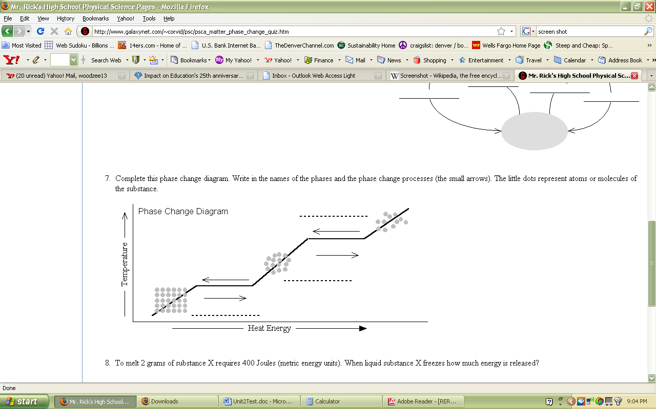

(Kinetic Energy)

Describe what the graph is showing when matter changes from a solid to a liquid. (Mini-PACER) **_________________________________________________________________________________________________________________________________________________________________________________________________________________________________________________________________________________**

As Kinetic Energy _______________________, Temperature _______________________, and particles move ____________________________.

Why do you think the graph has two areas where heat energy is added but temperature remains the same (the flat areas)? What do you think is happening here? (Mini-PACER) _________________________________________________________________________________________________________________________________________________________________________________________________________________________________________________________________________________

**EXPLAIN**:

9. Is the kinetic energy of a substance greater in a gas, liquid or solid? Why? (Mini-PACER) ____________________________________________________________________________________________________________________________________________________________________________________________________________________________________________________________

10. Based on this activity, explain what revisions you would make to your prediction from page 1.

Solid:

Liquid:

Gas:

**EXTENSION:**

This simulation only simulates the particle models for solids, liquids and gases. Use patterns and evidence from this investigation to predict how particles would behave in plasma. What is the kinetic energy of the particles? What might you expect the temperature to be relative to a liquid or gas? (Mini-PACER)

____________________________________________________________________________________________________________________________________________________________________________________________________________________________________________________________________________________________________________________________________________________________________________________________________________________________________

In the box, draw a diagram of what you

think the particles in plasma behave like:

**Make a “States of Matter Flip Book! Cut at least 10 small and equal squares of paper. Starting with a solid, and progressing to a gas, show what happens to the particles as energy increases. Include labels of the state of matter, a source of energy (such as a fire or hot plate) and use color to show the motion and shape of at least 10 particles in a container.**

**Example:**

**MCj03332080000[1]**

**Solid**