Name Period
Newton’s 3rd Law of Motion Notes
Overview
Have you ever tried to teach a friend how to roller skate? It’s hard if you are both wearing skates. When your friend pushes against you to get started, you move too. And when your friend runs into you to stop, you both end up moving! To understand these movements you need to know Newton’s third law of motion.
Newton’s 3rd Law
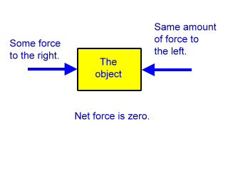
Before getting into Newton’s 3rd Law it is important to point out that the other laws we have studied deal primarily with forces acting on object.
Newton’s 3rd Law has object involved.
Newton proposed that whenever one object exerts a force on a second object, the second object back on the first object.
The force exerted by the second object is equal in and in direction to the first force.
Think of one force as the “ ” and the other force as the “ .”
Newton’s third law of motion states that if one object exerts a force on another object, then the second object exerts a force of equal strength in the opposite direction on the first object.
Another way to state Newton’s third law is that for every there is an but opposite reaction.
Action-Reaction Pairs
Pairs of action and reaction forces are all around you. When you jump, you push on the ground with your feet. This is an force. The ground pushes back on your feet with an equal and force. This is the force. You move up when you jump because the ground is pushing you.
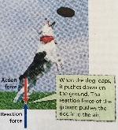
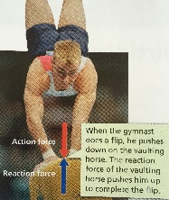
When the gymnast does a flip, he pushes down on the vaulting horse. The of the vaulting horse pushes him up to complete the flip.
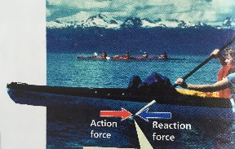
When the dog leaps, it pushes down on the ground. The reaction of the ground pushes the dog into the air.
The kayaker’s paddle pulls on the water. The reaction force of the water back on the paddle, causing the kayak to move.
Now you can understand what happens when you teach your friend to roller skate. Your friend exerts an when he pushes against you to start.
You exert a in the opposite direction.
As a result, both of you move in directions.
Detecting Motion
Can you always detect motion when paired forces are in action?
The answer is no.
For example, when Earth’s gravity pulls on an object, you cannot detect Earth’s and reaction.
Suppose you drop your pencil. Gravity pulls the pencil . At the same time, the pencil pulls the Earth with an equal and opposite reaction force. You don’t see Earth accelerate toward the pencil because Earth’s is so great that its acceleration is too small to notice.
Do Action-Reaction Forces Cancel?
Earlier you learned that if two equal forces act in opposite directions on an object, the forces are .
Because the two forces add up to zero, they each other out and produce no change in motion.
Why don’t the action and reaction forces in Newton’s 3rd law of motion cancel out as well? After all, they are equal and opposite.
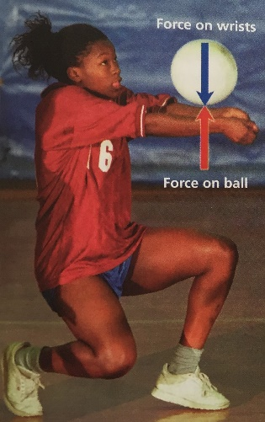
The action and reaction forces do not cancel out because they are acting on objects.
Look at the volleyball player. She exerts an upward action force on the ball. In return, the ball exerts an equal but downward force back on her wrists. The action and reaction forces act on objects.
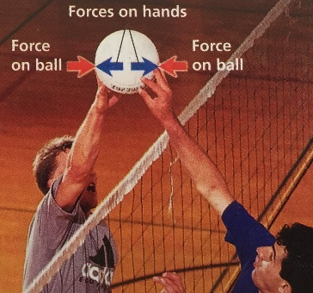
On the other hand, the volleyball players on the right are both exerting a force on the object – the volleyball.
When they hit the ball from opposite directions, each of their hands exerts a on the ball equal in strength but opposite in direction.
The forces on the ball are and the ball does not move either to the left or right.

