Name Period Date
Newton’s 1st Law – A Body in Motion
STARTER: Finish this sentence using your knowledge of Newton’s 1st Law
A body in motion will…..

In this experiment you will try to drop an object on a target as you run past the target. Think it’s easy?
Before you begin, try to guess what will happen. Try to figure out when you will need to release the ball in order to hit the target. Write down your predictions here and give the reasons why you think you are correct:

As you conduct this experiment, think of the challenges Air Force pilots had before the invention of the guided missiles that are used today. Pilots in World War II had to understand mathematics in order to drop bombs on targets while causing as little harm as possible to surrounding buildings and people. These are the same concepts that you will learn with this experiment.
Materials
You will need the following items for this experiment:
• one tennis ball
• clearly-marked target(s), i.e., notebook paper, a chalk mark, or tape
Procedure  1. Place a target about 10-15 meters away from a starting line. Mark the starting line with chalk or tape. | 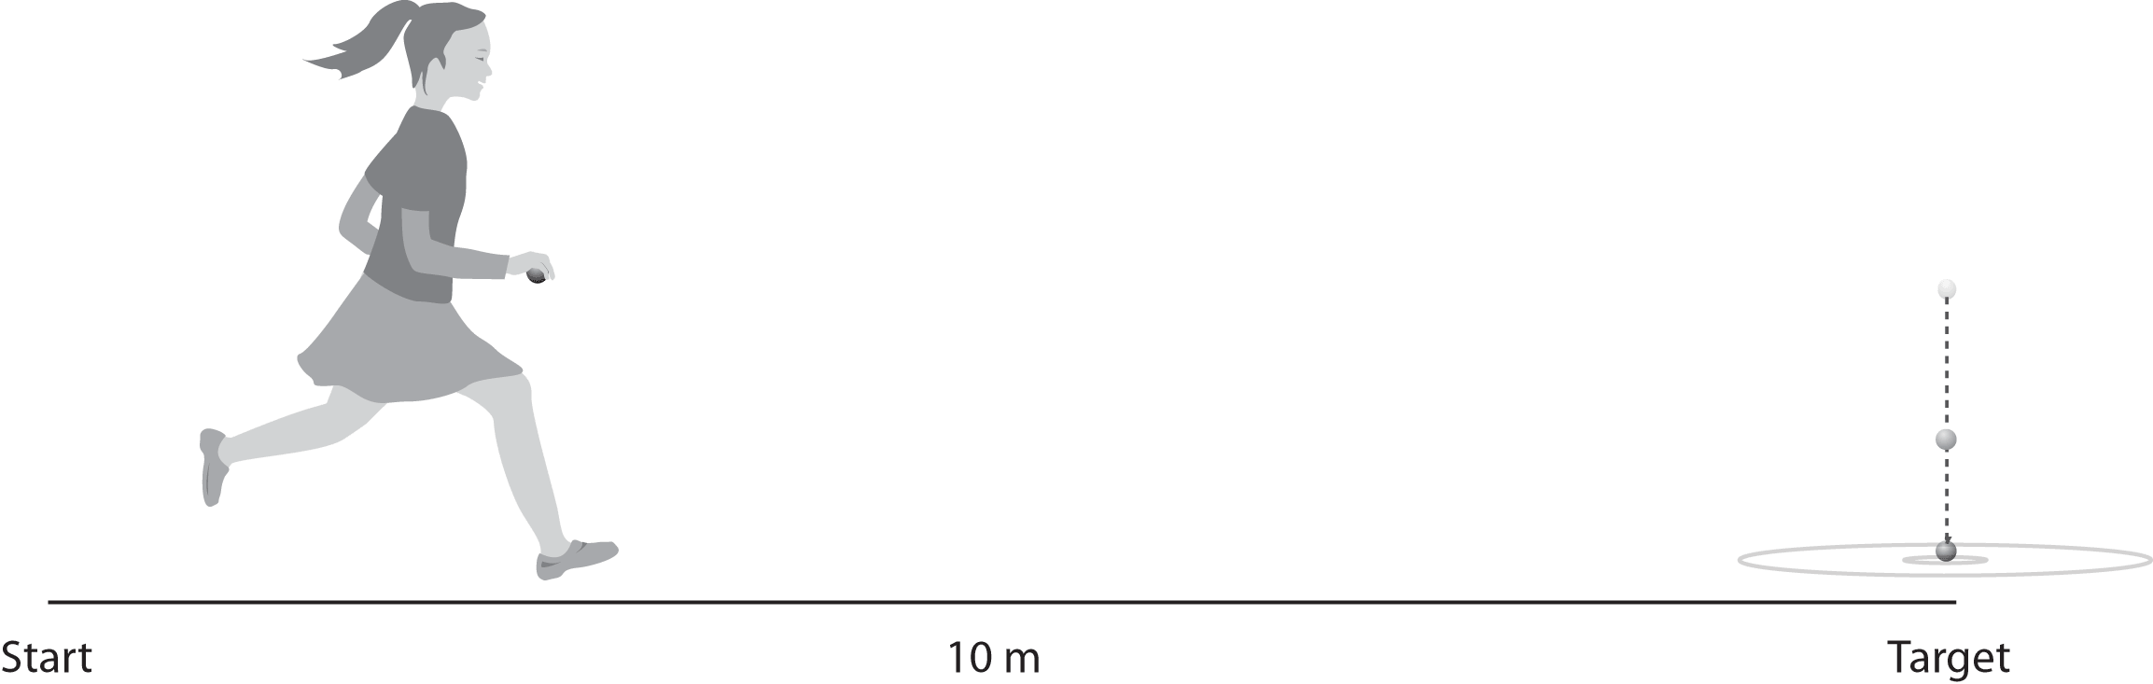
2. Hold the tennis ball and do not let your elbow leave your side as you run and drop the ball. Do not throw the ball. You should hold the ball from its sides so that you can release your grip as you let it drop. Remember to drop the ball and not throw it, otherwise you will change the intent of the experiment.
3. Have three students stand alongside (but slightly back from) the running path to act as observers. One should stand before the target, one at the target, and one just after the target. Their objective is to determine exactly where the runner released the ball and where the ball strikes the ground.
4. Ask the runner to sprint toward the target as fast as she or he can and try to drop the ball so that it lands on the target.
5. Next, have the observers make a diagram of where the ball was released and where it landed. Repeat the experiment until the ball hits the target.
6. Use the information in Step 5 to predict what would happen if a student ran at a slower speed.
7. Repeat Steps 4-5, using a different runner sprinting at a slower speed.
8. Use the information in the previous trials to predict what would happen at a walking speed.
9. For the last trial, ask a student to walk toward the target. Repeat Steps 4-5.
Write a summary of your results. Form conclusions based on the speed of each runner, the location of each ball’s release, and the exact point where each ball landed.

