Name Period Date
Motion Study Guide
Use the motion graph to answer the following questions:
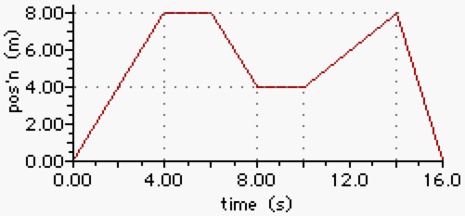
1. What is the total distance the object traveled?
2. What is the total time it took the object to move this distance?
3. What is the average speed of the object? (Show how you set up the equation)

4. Between which points does the object stop moving?

5. How many times does the object change directions?
6. Is the object going a constant velocity between points A and B? How do you know?

7. What is the average velocity of the object between points A and D? (Show how you set up the equation)

Use the velocity graph to answer the following questions:
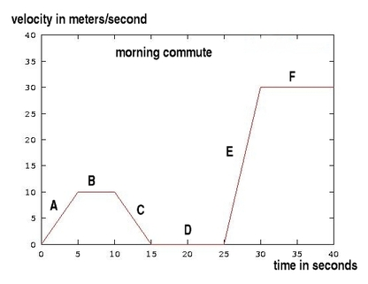
8. Which line(s) show(s) a constant velocity?
9. Which line(s) show(s) that the object has stopped moving?
10. Which lines show the object having a positive acceleration?
11. Which lines show the object having a negative acceleration?
12. What is the velocity for line B?

Answer the following questions:
13. Explain the difference between instantaneous speed and constant speed.

14. Define speed and explain how to measure it.

15. What is the equation for finding the average speed?

16. How is velocity different from speed?
17. Define acceleration and explain how to calculate it.

18. What are two ways you can change acceleration?

Draw what the other graph would look like for the graph that is given (for example: if a distance vs. time graph is shown, draw the velocity vs. time graph that would show that same motion).
19. Distance vs. Time Velocity vs. Time

20.

21.

