Mitosis Notes

- Mitosis is when body cells divide to make new body cells
- Body cells are also called somatic cells
- Mitosis is also called asexual reproduction

Vocabulary
Chromosomes: structures in the nucleus that are made of DNA (this is when DNA is super-coiled or wound up tightly)
Nuclear membrane: membrane around the nucleus that controls what can enter and leave the nucleus
Centrioles: structures in the cell that act as anchors for the spindle fibers
Spindle fibers: act like ropes to pull pairs of chromosomes apart
Centromere: the place where pairs of chromosomes are held together
Cytokinesis: the splitting of the cell into two new cells that occurs after mitosis

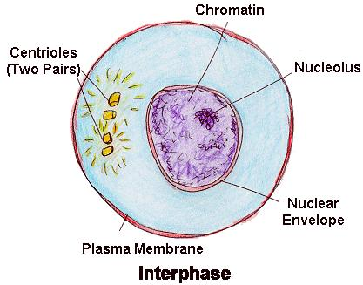
Phases of Mitosis
Interphase
- Cells spend most the most time in this phase
- Cell grows and gets ready to divide
- DNA is in its relaxed form called chromatin
- At the end of interphase the chromosomes are copied

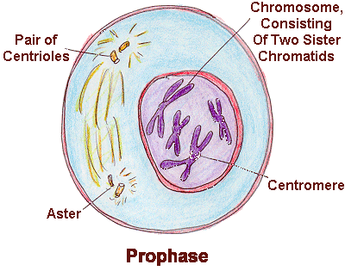
Prophase
- Chromosomes become visible
- Nuclear membrane disappears
- Centrioles move toward opposite ends of the cell
- Spindle fibers form between the centrioles
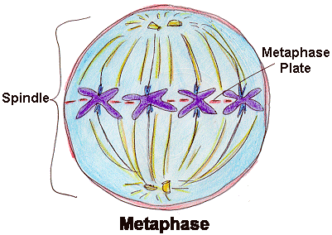
Metaphase
- Chromosomes line up in middle of the cell
- Spindle fibers attach to the centromeres

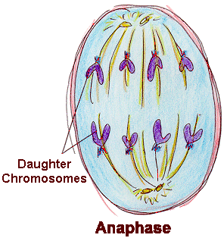
Anaphase
- Chromosomes are pulled apart from their copy at the centromere
- Separate strands of DNA move away from each other to opposite ends of the cell

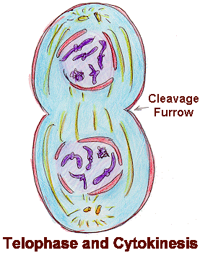
Telophase
- Centrioles and spindle fibers disappear
- Chromosomes stretch out and become harder to see
- Nuclear membrane forms around each group of chromosomes to form two new nuclei
- After mitosis has ended, the cell goes through cytokinesis and forms two new, genetically identical cells

