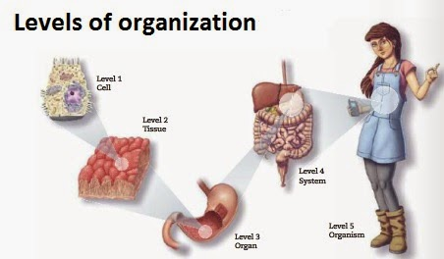

TERM | DEFINITION | EXAMPLES
CELLS

TISSUES

ORGANS

ORGAN SYSTEMS

ORGANISM

