Human Traits Survey
Let’s look at some of the traits that people have. You need to complete the survey for yourself and ALSO for one other person. You will need a ruler.
Traits measured in centimeters:
Trait | Self | 1:
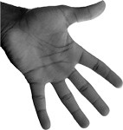
Hand span – distance
from tip of pinkie to tip of thumb when hand is fully stretched
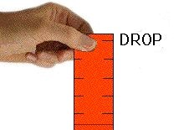
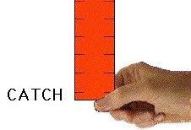
Reaction time – number of centimeters that passes before you can catch a falling ruler
(best out of 3)
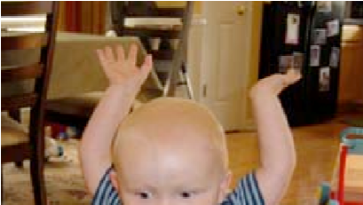
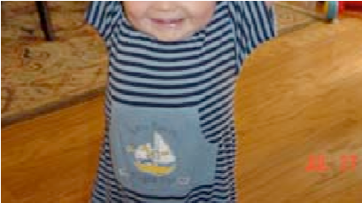
Reach – how far up a wall can you touch with your fingertips when standing on tip toe
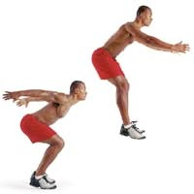
Broad jump – how far can you jump with your feet together if you start standing still

Yes or no/Multiple choice traits:
Trait | Self | 1:
Eye color – what color are your eyes? | brown blue green hazel | brown blue green hazel
Freckles – do you have freckles? Say “yes” only if you have LOTS of freckles all over your nose and cheeks. Sun freckles do not count. | yes no | yes no
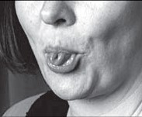  Tongue rolling - can you roll your tongue into a tube? | yes no | yes no
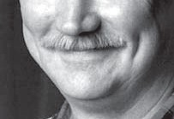  Dimples – do you have dimples on your cheeks? | yes no | yes no
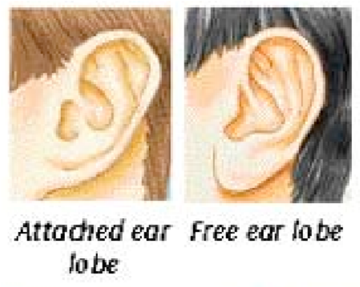  Earlobe attachment – are your earlobes attached to the side of your face? | yes no | yes no
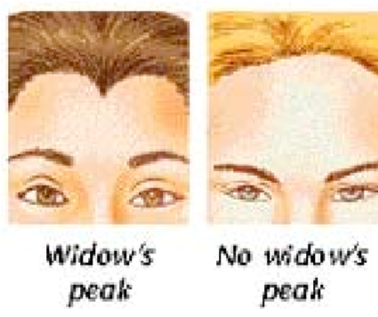  Widow’s peak – do you have a widow’s peak (hairline has a V)? | yes no | yes no
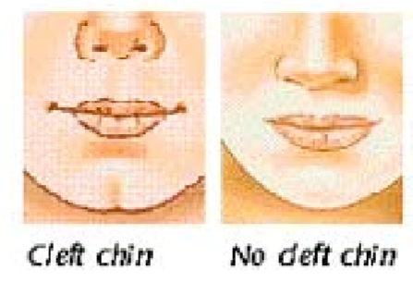  Cleft chin – do you have a cleft chin? | yes no | yes no
Hair color – what color is your hair? | black brown blond red | black brown blond red
Hair texture – what is the texture of your hair? | curly  wavy  straight | curly  wavy  straight

