Genetics and Heredity Notes
Remember when we learned about meiosis? We learned that to make a new organism, of the chromosomes come from and of the chromosomes come from . (This is why have only the chromosomes that cells have). This is how information is transferred from parent to offspring.
- Offspring: the
Determining the Sex of Offspring
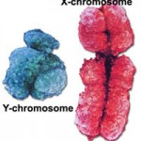
Before we get into how inheritance of genetic traits works, we first need to understand how you become either male or female.
- There are that determine the of an individual.
- We call them the and chromosomes because they look like the letters and !
Females have X chromosomes
Males have X and Y chromosome.
Females produce that have only an chromosome. (Mom has two X chromosomes – they are and will pair up during the first part of . Through the process of meiosis, the matching pairs get and put into different cells.)
Males produce that have either an or a chromosome. (Dad has an X and Y chromosome – they are matching pairs as well).
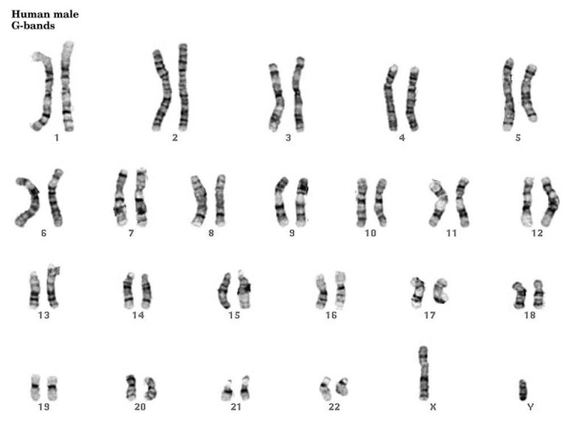
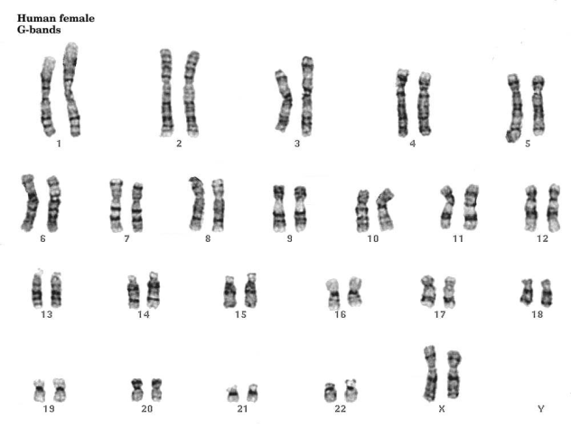

+ =

+ =

There is a chance that an offspring will be or . Each time a couple has a baby, they have a chance of having a and a chance of having a .
Let’s explore this concept a bit further with a brief activity.
- Flip a coin 10 times and mark your results for each flip
- Try to predict the next coin flip
- Flip your coin 20 more times
- Count up how many times you saw each side of the coin. Are the numbers close?
- Now find the percentage for each side of the coin. (How many time you saw one side divided by the total number of flips X 100). Are you close to 50%?
- What do you predict the percentage would be if we used the data from everyone in class? Would it be closer to 50%?
- Did the previous flips affect the next flip?

The concept we just explored with the coin flip is called .
is the chance that something will happen – how likely it is that some event will happen. You can measure probability with a (50% chance of being a boy or girl) or with a (50:50 chance of being a boy or girl).

Heredity of Traits
is the passing of traits from to
Traits are controlled by (sections of that code for making specific proteins that affect the traits of an individual).
When matching pairs of separate into sex cells during , matching pairs of also separate.
As a result, each ends up with one form of a gene for each trait that an organism shows. This gives us .
If the trait is for , then the in one sex cell (say, the ) may control one form of the trait, such as . The gene for eye color in the other sex cell (the ) may control a different form of the same trait, such as .
The different forms a may have for a trait are called .
The study of how traits are inherited through the combining of is the science of .
Many times there are just forms of an allele. Examples include:
- Hitchhiker’s vs. thumb
- Straight vs.
In each of these examples, there are only two possibilities for alleles.
Let’s explore some of these traits that are controlled by just with an inherited traits survey.
Each parent provides an for a trait. For example, mom could provide the allele for and dad could provide the allele for .
What would their child have, a hitchhiker’s thumb or a straight thumb?
There is a way to figure out the percent chance that the child will have a hitchhiker’s thumb or a straight thumb.
To figure out the probability that an offspring will have a certain trait you can use a
.
Punnett Square
Making a Punnett square is kind of like a game or puzzle. Games and puzzles have rules. Here are the rules for making a Punnett square:
1). Represent the alleles with a . Example: H for hitchhiker’s thumb
2). Always use the letter for the alleles of a trait. Example: h for straight thumb (instead of s).
3). Use letters for the allele, and lower case letters for the allele.
- Dominant = the allele that dominates or hides the other allele (it is the allele that is expressed)
- Recessive = the allele that gets hidden by the dominant allele but appears (is expressed) when not paired with a dominant allele.
4). Draw the Punnett square box and write the alleles provided by each parent along the top and side.

Problem: Tall is dominant over short. Cross a purebred tall plant (TT) with a purebred short plant (tt).
- Purebred means that their alleles are the .

Problem: Purple flowers are dominant over white flowers. Cross a purebred purple with a purebred white.

Genotypes vs. Phenotypes
By representing alleles using letters, you get the of the offspring. The genotypes of all the offspring of the purebred tall and purebred short plants was .
: An organism’s genetic makeup, or allele combinations
The of an organism is its physical appearance. For example: Being tall or having white flowers.
Problem: Tall is dominant over short. Cross a purebred tall plant (TT) with a purebred short plant (tt).

Problem: Cross the hybrid offspring of the tall and short plants. means that their alleles are different.

We can name the various genotypes. If the alleles are both the (what we called purebred earlier), then we call the genotype . For example: TT or tt.
If the alleles are (what we called hybrid earlier), then we call the genotype . For example: Tt.
Tt =
TT =
tt =
How can we tell the two homozygous ones apart?
Tt =
TT =
tt =

Gregor Mendel
Gregor was an Austrian Monk who is considered to be the father of genetics. Mendel began experimenting with in 1856. He thought it would be possible to predict the kinds of flowers and fruit a plant would produce. But something had to be known about the parents of a plant before a prediction could be made. Mendel recorded this information and then crossed specific plants by pollinating them himself. He recorded his data and after 8 years of research, he published a paper on his findings about dominant and recessive traits. Although he did not gain any notoriety in his lifetime, his work was rediscovered in 1900 by three other scientists who had reached similar conclusions.

Traits | Shape | Seed (pea) Color | Pod Color | Pod Shape | Plant Height | Flower Position | Flower Color
dominant | smooth | yellow | green | full | tall | leaf junctions | purple
recessive | wrinkled | green | yellow | flat | short | tips of branches | white

Problem 1: Cross a homozygous recessive wrinkled pea with a heterozygous smooth pea.

Problem 2: Cross a heterozygous yellow pea with a homozygous dominant yellow pea.

