Name Period Date
Ectrodactyly
Formerly known as “lobster claw hand, ”individuals with this disorder have a cleft where the middle finger or toe should be. These split-hand/split-foot malformations are rare limb deformities which can manifest in any number of ways, including cases including only the thumb and one finger (typically the little finger or little finger). It’s also associated with hearing loss. Genetically speaking, it’s caused by several factors, including deletions, translocations, and inversions in chromosome 7.
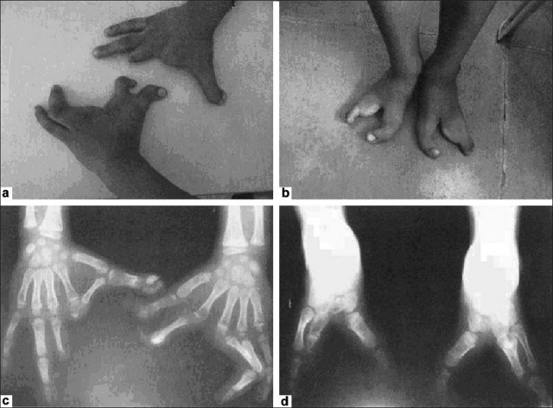
A 2007 ABC article featured Bree Walker, a television anchorwoman living in Los Angeles who lives with the disease. Walker also appeared on the television show “Nip/Tuck” as a character with ectrodactyly who helps a family with the disorder. Thankfully, surgical procedures can correct some of these malformations.

Write a 3 sentence summary of the article:

