# Changes of State Notes

As we have discussed, matter can exist in ______________ different forms: _______________, ________________, ________________, and _________________.

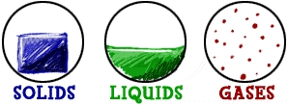

The three forms we observe in the 8th grade science lab are:

When a substance changes from one state (form) to another, this is called a __________________________.

During a change of state, the _____________________ of a substance changes. The energy is related to the movement of particles.

Which particles have the most energy: those in a solid, a liquid, or a gas? ___________

|  |  |  |
| --- | --- | --- |
| **Movement** | **Energy** | **Temperature** |
| Fast |  |  |
| Slow |  |  |

If ___________________ is added to a material, then the particles will move __________________ and the temperature will _______________________.

If _________________ is taken away from the material, then the particles will move ________________ and the temperature will _______________________.

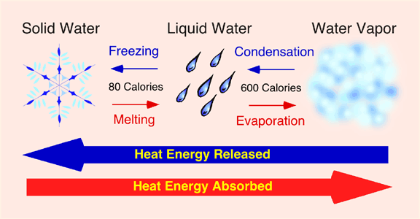

**5 Examples of Changes of State**

**1) Melting** – a change from ______________________ to ________________________

* **Melting point** – temperature at which a substance changes from a solid to a _____________________.
* When something to melts, heat is _____________ and the particles begin moving ___________________.

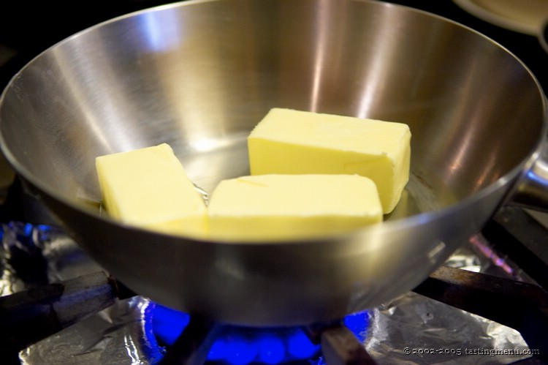

Draw the particles’ change: **melting**

**2) Freezing** – a change from ______________________ to _______________________

* **Freezing point** – temperature at which a substance changes from liquid to _____________________.
* When something to freezes, heat is _________________ and the particles begin moving ___________________.

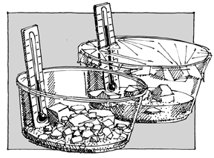

Draw the particles’ change: **freezing**

“-ization” means ____________________

**3) Vaporization** – a change from ______________________ to _____________________.

* There are two ways for a material to ______________________.
* Boiling – vaporization that occurs throughout a ____________________.
* **Boiling point—**temperature at which a liquid becomes a _______________.
* 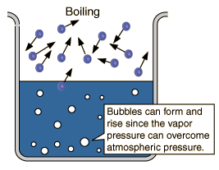Evaporation – vaporization that occurs at the _________________ of a liquid when the liquid is below its boiling point
* When something to vaporizes, heat is usually _________________ and the particles begin moving ___________________.

Draw the particles’ change: **vaporization**

**4) Condensation** – a change from ______________________ to _____________________.

* **Condensation point** – temperature at which the gas becomes a _________________. The condensation point of a substance is the same as its ________________________________.
* When something to condenses, heat is _________________ and the particles begin moving ___________________.

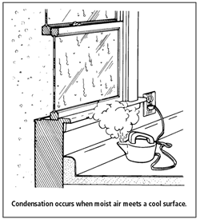

Examples: mirror after a shower, breathing in the winter time

Why do water vapor particles condense when they travel from the shower and hit the glass of a mirror?

Why does your breath cloud up when you breath outside in the winter?

Draw the particles’ change: **condensation**

**5) Sublimation** – change from ___________________ directly to a _________________ (skipping the _____________ state).

* Sublimation causes particles to move much ____________________.

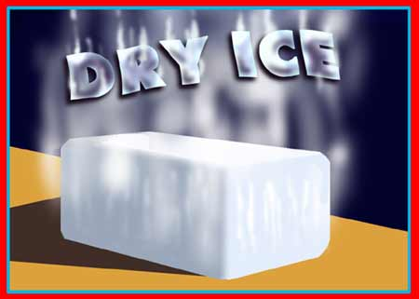

Draw the particles’ change: **sublimation**

**Summary:**

