Changes in State
There are three states of matter that we know about: solids, liquids and gases. Each of these states is made up of particles that move by different amounts.
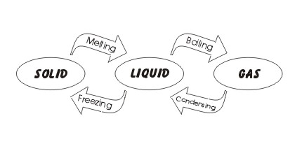 | State Changes  All solids, liquids and gases are made of particles. The only difference between them is how much energy the particles have. If you give the particles energy; or take energy away from them; then you can change their state.  If you heat up a solid - you give it some energy. This causes the particles to move more and the solid to change into a liquid, or melt. If the liquid is heated then it may evaporate and turn into a gas.  Taking energy away from a gas (cooling it down) may cause it to turn into a liquid - or condense. Further cooling of the liquid may cause it to turn into a solid - or freeze.

Energy Changes
To change a solid into a gas you need to give the solid particles a lot of energy, the particles need more energy to turn from a liquid into a gas.
If you want to make a solid warmer then you give it some heat - the graph shown here describes this. The change from a solid to a liquid requires heat energy but the temperature doesn't rise. There isn't an increase in temperature because the energy is all used in changing the particles from a solid to a liquid.  The same thing happens when the particles change from a liquid to a gas - at first the heat given to the liquid just causes it to warm up. Then any more heat given does not cause the temperature to rise because it is all used to change state from liquid to gas. | 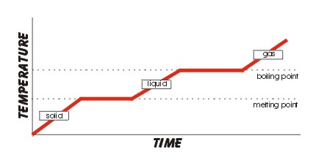

Answer these questions ...
- What are solids, liquids and gases made out of? __________________________________________
- Are the particles moving or still? ______________________________________________________
- Do the gas particles move more or less than in a liquid? ___________________________________
- Do the gas particles move more or less than in a solid? ____________________________________
- A change from a solid to a liquid is called what? _________________________________________
- A change from a liquid to a gas is called what? __________________________________________
- A change from a gas to a liquid is called what? __________________________________________
- A change from a liquid to a solid is called what? _________________________________________

... and now these questions
- Liquid particles are always doing what? ________________________________________________
- If liquid particles are heated do they move more or less? __________________________________
- If you give heat energy to a liquid will it change into a gas or a solid? ________________________
- What is the name of the process when a liquid changes into a gas? __________________________
- If liquid particles lose energy do they move more or less? __________________________________
- When a liquid loses energy will it change into a gas or a solid? ______________________________
- What is the name of the process when a liquid changes into a solid? _________________________
- Which particles have the most energy a solid, liquid or a gas? ______________________________

