|  |  |  |  |  |  |  |  |  |  |  |  |  |  |  |  |  |  |  |  |  |  |  |  |  |  |  |  |  |
| --- | --- | --- | --- | --- | --- | --- | --- | --- | --- | --- | --- | --- | --- | --- | --- | --- | --- | --- | --- | --- | --- | --- | --- | --- | --- | --- | --- | --- |
| **2. Background Research: Describe what I know about the problem that could impact the experiment.**   1. Matter comes in _**THREE**_________main forms (states). These states of matter are: ___**SOLID**____________, ____**LIQUID**_________________ and ____**GAS**_________________. **(Bonus states of matter: plasma and Bose-Einstein Condensate)** 2. Two factors affect the state of matter. ___**TEMPERATURE (ENERGY)**__ and _____**PRESSURE**___________ determine what state a particular type of matter is in. 3. When matter changes state, this is a ____**PHYSICAL CHANGE**_____________change. When matter undergoes this change, it is still the ___**SAME**________________type of substance. The particles simply get _**FASTER**___________ or _____**SLOWER**___________. 4. **Complete the chart:**  |  |  |  |  | | --- | --- | --- | --- | | Change of State | Direction  (starting state to ending state) | Endothermic  (Energy is absorbed)  or  Exothermic (Energy is released) | Example | | Melting | Solid -> Liquid | Endothermic | Ice melting in soda | | Freezing | Liquid -> Solid | Exothermic | Water freezing into ice | | Boiling  (Vaporization) | Liquid -> Gas | Endothermic | Boiling water to make Mac&Cheese | | Condensation | Gas -> Liquid | Exothermic | Water on the outside of a cold glass | | Sublimation | Solid -> Gas | Endothermic | Dry ice at a Halloween Party | | Deposition | Gas -> Solid | Exothermic | Frost forming on a leaf when it is cold | |

**MCj04039250000[1]MCj03979030000[1]MCj03970220000[1]MCj04039970000[1]**

1. **Draw particles showing the process of melting - freezing, boiling - condensing, and sublimation -deposition. Label each box and arrow. Show where energy is added and where energy is taken away.**

**S**

**Particle Models must show:**

**Shape/Arrangement**

**Volume**

**Energy/Motion**

**Deposition**

**Sublimation**

**Condensation**

**Freezing**

**Melting**

**Boiling/ evaporation**

**L**

**S**



**G**

**L**

**L**



**S**

**S**

**G**



Solid gas condensation boiling deposition

Liquid plasma evaporation sublimation

Bose-Einstein Condensate freezing melting

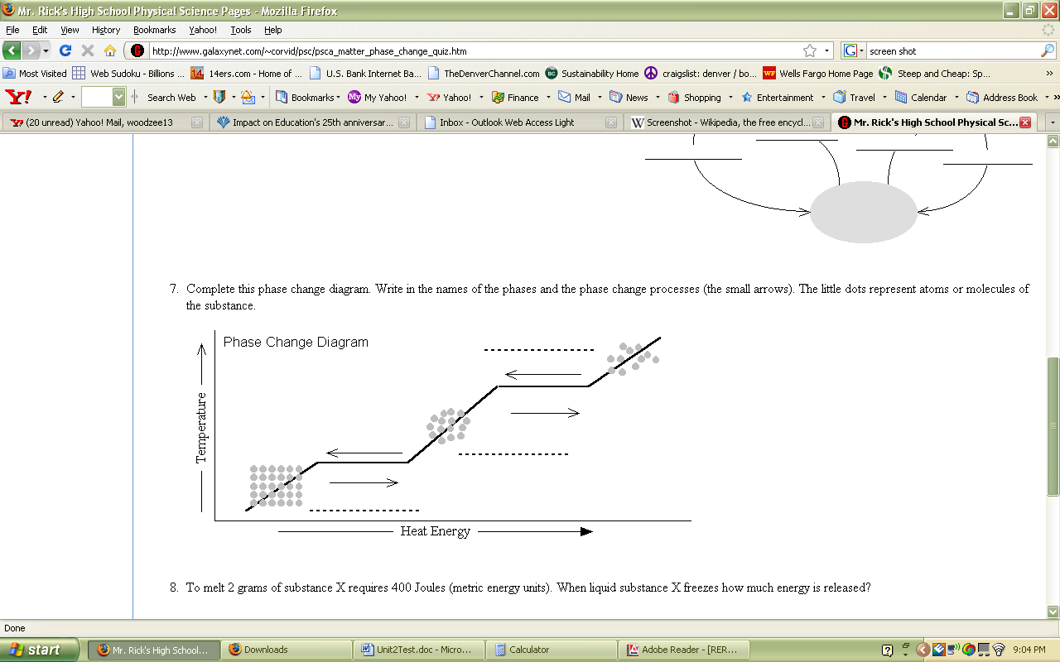

**Plasma**

**Bose-Einstein Condensate**

**Gas**

**Condensation**

**Melting**

**Solid**

**Liquid**

**Boiling/Evaporation**

**Freezing**

(Kinetic Energy)