The Story of Cellular Respiration It all started with the sun

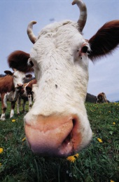



Yummy!

Stage 1of Cellular Respiration Stage 2 of Cellular Respiration

Setting: Setting:

Panning Shot We get the following products at

Stage 1 Stage 2

THE

END

Hmm…then what happens?