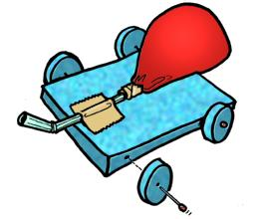
Balloon Powered Race Cars
Objectives:
- to create a balloon powered race car for maximum speed and
distance
- to incorporate Newton's Laws of Motion
- to learn how to use the formula Speed= Distance / Time
Materials:
- 9 inch balloon is standard
- pen barrel or straw
- various materials to construct the racers
- Grading Rubric (PDF)
Rules:
- The car must be powered by no more than 2 balloons.
- You can build the car out of anything.
- It must have at least three wheels. Wheels are defined as anything that is round and goes around.
- The wheels can not be wheels from a toy car. They must be made out of something that was not originally meant to be used as wheels.
- The car may not leave the ground.
- The car must be capable of traveling at least 5 meters.
Procedure:
- You will bring in materials from home and assemble your car in class.
- On race day we will set up a track in our classroom.
- You will race in pairs against other classmates.
- Cars that follow all of the rules will be eligible for awards.
- These awards will be given in three categories.
- Best Looking Car
- Fastest Car (in first 5 meters)
- Farthest Distance Traveled
Good Luck!

This activity was inspired by Mr. Bings Physical Science Class.
This is his page: http://www.ahsd25.k12.il.us/School%20Info/South/Southfiles/Bingaman/motion/balloon/racers.htm
Helpful Links:
http://pbskids.org/zoom/freeloads/ballooncar.html
http://www.kyrene.k12.az.us/schools/Pueblo/Tech/balloon_car.htm
http://www.alaska.faa.gov/flt_std/aved/teachers/Rcar.html
http://library.thinkquest.org/50109/projects/bcars.html
http://www.eecs.umich.edu/mathscience/funexperiments/agesubject/lessons/other/rocket_car.html

